Site 136293 - Land at and to the rear of 7 Shefford Road
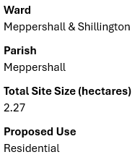
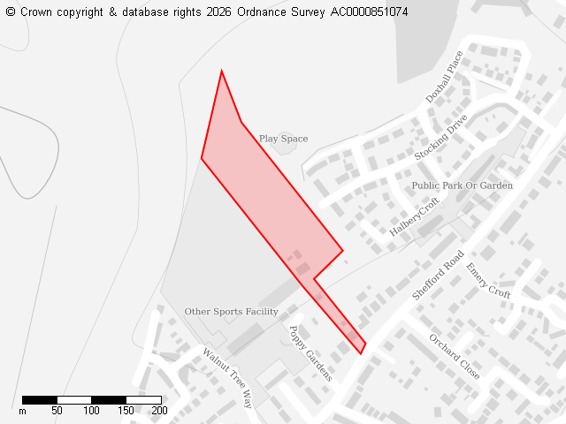
Development would:
- Create permanent, urbanising encroachment beyond defined settlement envelope into rural, open countryside eroding the unsettled elevated village hilltop ridgeline, that would not respect, retain or enhance character, appearance and distinctiveness of local landscape character area.
- Remove Grade 2 BMV agricultural land
- Connect to foul drainage network with insufficient capacity
- Adversely affect elevated views from/to village across adjacent vales and intervening low ground
- Push building line beyond adjacent developments in East/West
- Harm landscape character and visual environment.
- Contradict the Landscape Strategy for the character area.
Contradicts Policies CBLP SP7, CC6, CC8, HQ1, EE5 and LCA guidelines. CBC previously refused.
MPC may look to support this site if:
- the line of development (building line) did not extend beyond adjacent development to the East/West.
- homes on the site are bungalows to the rear and no dwelling on site greater than 2 stories high.
- the green open space at the rear of the site extending along the village ridge line is transferred to the Parish Council creating a connected and extended green open space from Centenary Field to the rear of the Village Hall across to and including Woodlands Rest.

Site 136328 - Land between Shefford Road and Sandy View (Proposed use - Residential)
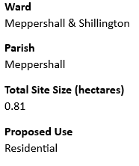
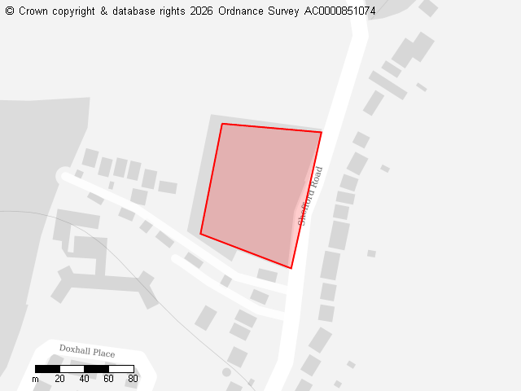
Development would:
- Create significant built form/mass onto greenfield land outside settlement envelope at village edge.
- Alter visual impact/environment of transition from village to open countryside.
- Deviate from linear pattern of development along Shefford Road creating permanent/noticeable visual harm to landscape character.
- Fail to integrate with adjacent wooded area and rural context beyond.
- Not suitably conserve priority habitat forming deciduous woodland (site vegetation cleared) and harm biodiversity.
- Be unsustainable as distance from village amenities creates car dependency.
- Not connect to footpaths.
- Create highways safety issues as access on road bend.
Contradicts Policies SP7, EE2, EE4, EE5 and HQ1. PInspector previously dismissed.

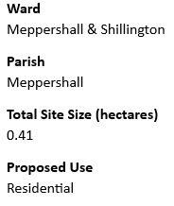
Site 136388 - Stondon Road Glasshouses (Proposed use - Residential)
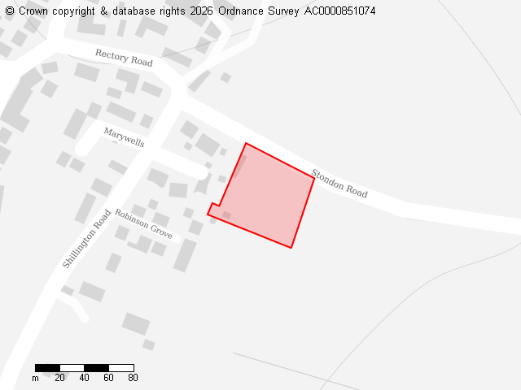
Site 136388 - Stondon Road Glasshouses (Proposed use - Residential)
Development would:
- Create highways safety issues as site entrance at narrow point in highway with no room for pedestrian link to Shillington Road/High Street.
- Create significant built form/mass outside settlement envelope at village edge.
- Be unsustainable as distance from village amenities creates reliance on cars.
- Alter visual impact/environment of transition from village to open countryside.
- Create overlooking and visibility of village as homes would be built on elevated ground due to site topology.
MPC may look to support this site if:
- Height of homes were limited so as not to create overlooking and alter the village skyline.
- As it would not be developing agricultural land but transform a brownfield site.
- Development and design were sympathetic to the adjacent conservation area.

Site 136390 - Land East of Coneygate stretching from Stondon Road to Fildyke Road (Proposed use - Residential)
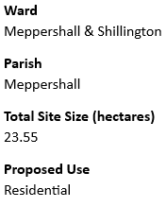
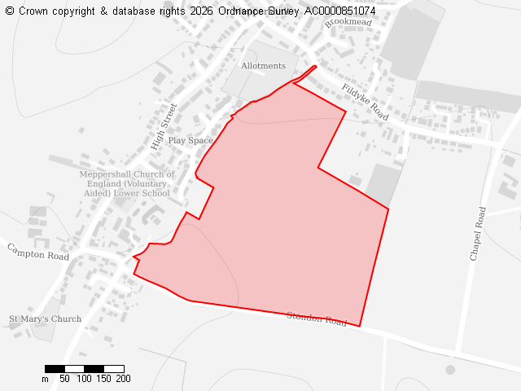
Development would:
- Remove Grade 3a BMV agricultural land
- Create significant built form/mass into area of countryside high ground outside settlement envelope.
- Alter visual impact/environment of transition from village to open countryside along Stondon Road.
- Adversely affect the beauty of the countryside elevated views from/to village across adjacent vales/intervening low ground (Stondon, valley and out towards Stevenage Hospital)
- Be detrimental/harm rural landscape setting/appearance of the village
- Deviate from linear pattern of development along High Street creating permanent/noticeable visual harm to landscape character.
- Create overlooking as built on elevated ground due to site topology.
- Destroy ancient lynchet/grass footpath running Northwest/Southeast across site
Contradicts Policies CBLP SP7, HQ1, HQ8, EE5 and EE4 and LCA guidelines and MNP RC1, NE1, H1, DND1, GSR3

Site 136573 - Land between Chapel Road, Hoo Road Bridleway and North of Fildyke Road (behind woodland) (Proposed use - Residential)
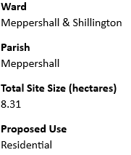
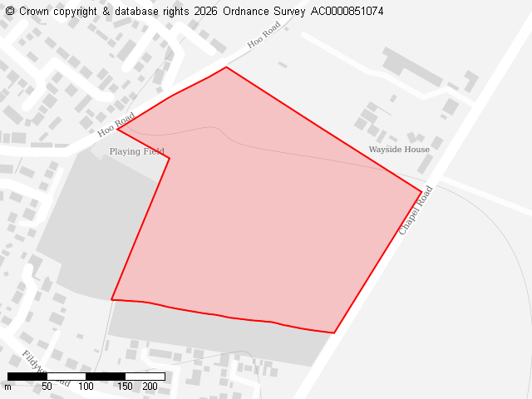
Development would:
- Create significant built form/mass in countryside outside settlement envelope.
- Deviate from linear pattern of development along village roads.
- Harm/not respect, retain or enhance character, appearance and distinctiveness of the local landscape character area contrary to the Landscape Strategy
- Alter visual impact/environment of village/transition from village to countryside.
- Lack village highway links, creating isolated, car-dependent community.
- Access from rural Chapel Road, 60mph road with no footpath and lined with hedges/ditches.
- Cause harm to future residents' living conditions via noise/disturbance from adjacent businesses.
- Enclose Old Road Meadow Nature Reserve harming wildlife, habitat and biodiversity, blocking green corridors/adding light pollution.

Site 136644 - Paddock and stables behind 70-80 Fildyke Road (Proposed use - Residential)
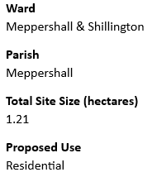
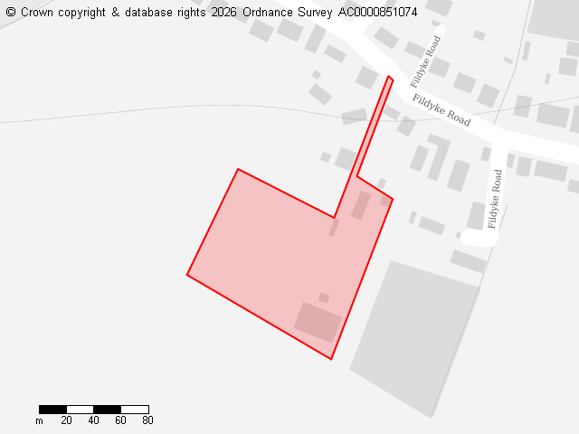
Development would:
- Create significant backland development and built form/mass in countryside outside settlement envelope.
- Deviate from linear pattern of development along Fildyke Road creating permanent/visible harm to landscape character contrary to the Landscape Strategy.
- Alter visual impact/environment of village and transition from village to open countryside.
- Create severe highways safety, capacity, and logistical challenges, most notably severe congestion and deadlock, emergency service and waste vehicle restrictions, and pedestrian vulnerability as primary access is via single-vehicle track.
- Create highways safety issues as access on bend in road and no footpath for connectivity.

Site 136652- Flints Field behind 40 Shefford Road (Proposed use - Residential, Stand-alone green spaces, Other)
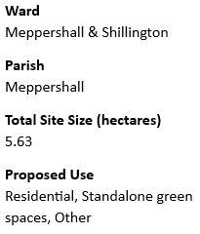
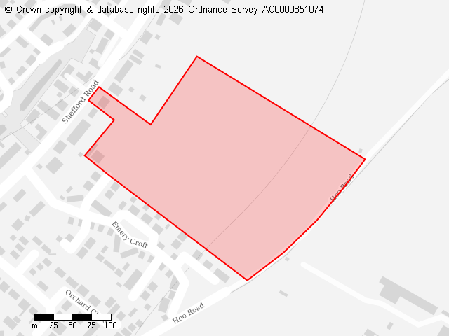
Development would:
- Create permanent, urbanising encroachment beyond defined north-easternmost extent of settlement envelope into rural, open countryside.
- Erode the unsettled elevated village hilltop ridgeline ribbon of development, rural identity, and local distinctive verdant character of the village and its setting
- Harm and not respect, retain or enhance character, appearance and distinctiveness of the local landscape character area contrary to the Landscape Strategy
- Create built mass down the unsettled slope towards the Hoo Road public bridleway.
- Be unsustainable as distance from village amenities creates car dependency.
Site previously refused at appeal APP/P0240/W/20/3249265

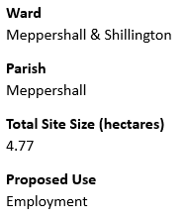
Site 136734 - ACO Site 1 (Proposed use - Employment)
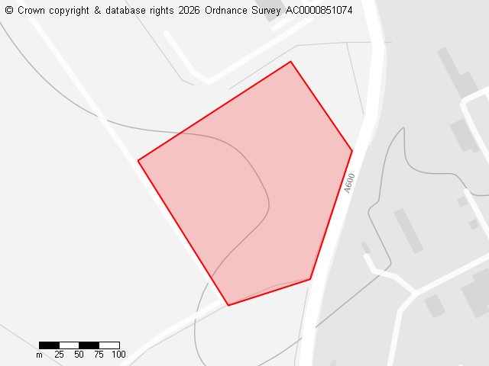
Development and expansion of site would be supported only if:
- Strict caps on floodlights/security lights to prevent light pollution in dark rural skies that is already an issue from the site.
- Site layout/design sympathetic to open countryside around the site blends into the rural landscape/natural surroundings.
- Planting of local, native trees and hedgerows to screen buildings and site and blend it into the countryside.
- Effects on biodiversity are mitigated either on site or in village of Meppershall.
- Existing trees of importance at site entrance are protected and retained.
- Existing trees of importance at site entrance are protected and retained.

Site 136749 - Land between Hoo Farm, Chapel Farm and Stanpit House off A600 (Proposed Use - Residential, Employment, Green energy)
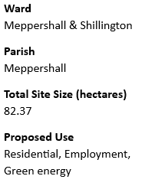
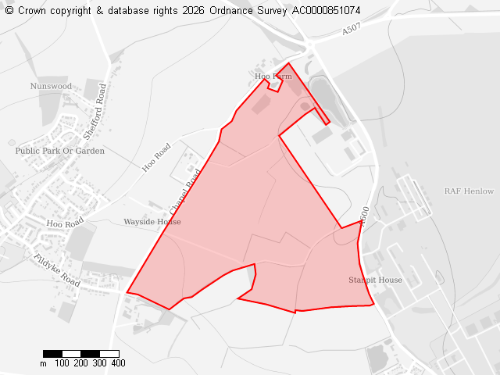
Development would:
- Be a permanent, urban encroachment far beyond village settlement envelope into rural, open countryside.
- Be unsustainable and have no connectivity to the village creating an isolated, car-dependent community.
- Risk coalescence and erode rural distinctiveness of separation between villages of Meppershall, Shefford, Henlow and Stondon.
- Alter visual impact/environment of village and transition from village to open countryside.
- Lack of safe walking, cycling or public transport connections to facilities e.g.: schools, healthcare and shops.
MPC may look to support this site for green energy and employment if:
- Strict caps on floodlights/security lights to prevent light pollution in dark rural skies that is currently an issue.
- Site layout/design sympathetic to open countryside and current commercial site and blends into the rural landscape and natural surroundings.
- Planting of local, native trees and hedgerows to screen buildings and site and blend it into the countryside.
- Effects on biodiversity are mitigated either on site or in village of Meppershall.
- Green energy is solar farm that has a direct benefit to the village. We object to a windfarm.

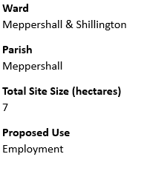
Site 136789 - ACO site 2 (Proposed Use - Employment)
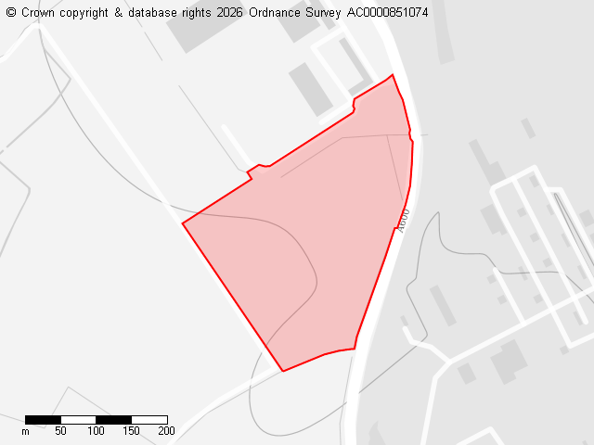
Development and expansion of site would be supported only if:
- Strict caps on floodlights/security lights to prevent light pollution in dark rural skies that is already an issue from the site.
- Site layout/design sympathetic to open countryside around the site blends into the rural landscape/natural surroundings.
- Planting of local, native trees and hedgerows to screen buildings and site and blend it into the countryside.
- Effects on biodiversity are mitigated either on site or in village of Meppershall.
- Existing trees of importance at site entrance are protected and retained.
- Existing trees of importance at site entrance are protected and retained.

Site 136808 - Land between A507, Chapel Road and Shefford Road (Proposed Use - Residential, Employment, Green energy)
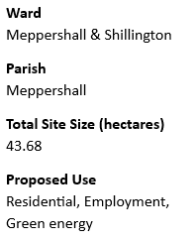
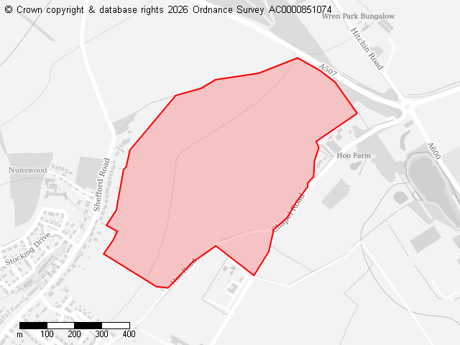
Development would:
- Create permanent, urbanising encroachment beyond defined north-easternmost extent of settlement envelope into rural, open countryside.
- Erode the unsettled elevated village hilltop ridgeline ribbon of development, rural identity, and local distinctive verdant character of the village and its setting
- Harm and not respect, retain or enhance character, appearance and distinctiveness of the local landscape character area contrary to the Landscape Strategy
- Be unsustainable and have little connectivity to the village creating distant, isolated, car-dependent community.
- Risk coalescence and erode rural distinctiveness of separation between Meppershall and Shefford.
- Alter visual impact/environment of village and transition from village to open countryside.

Site 136896 - Airman site (Proposed Use - Residential)
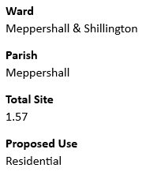
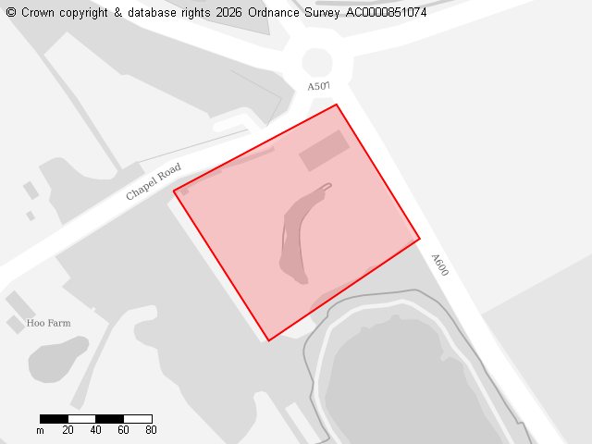
Development would:
- Be a permanent, urban encroachment far beyond village settlement envelope into rural, open countryside.
- Alter visual impact/environment of transition from village to open countryside.
- Be unsustainable and have little connectivity to the village creating distant, isolated, car-dependent community.
- Lack of safe walking, cycling or public transport connections to facilities e.g.: schools, healthcare and shops.
- Not suitably conserve priority habitat forming deciduous woodland (site cleared of vegetation) and harm biodiversity.
- Alter visual rural impact/environment of the Airman roundabout and surrounding area.
- Risk residential coalescence and erode rural distinctiveness of separation between Meppershall and Shefford.

